1. d
2. 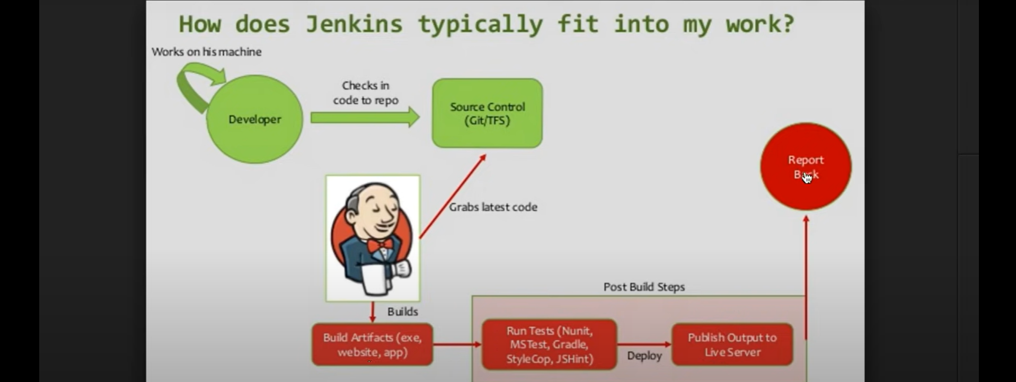
3. Let’s download, configure and run Jenkins
4. Download Jenkins.war file and run 🡺 java -jar jenkins.war  
   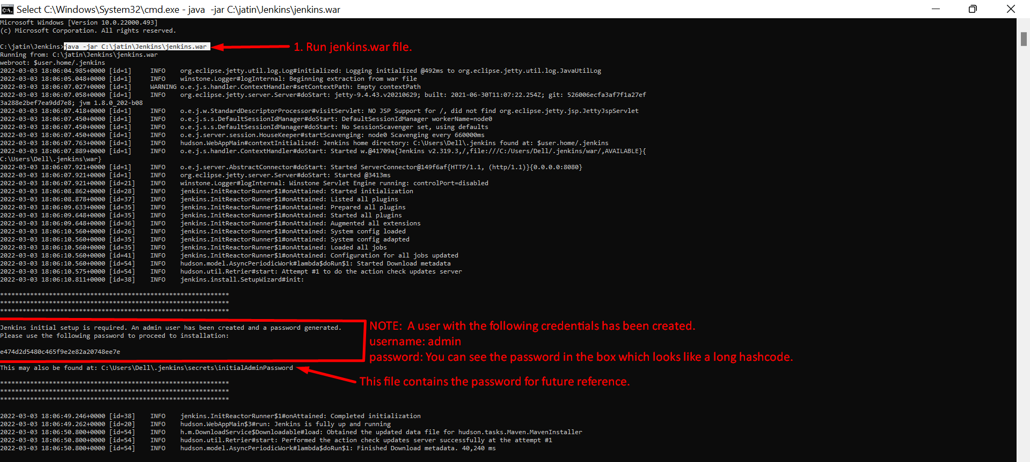
5. Open localhost:8080 which will redirect to the login page and enter the above password  
   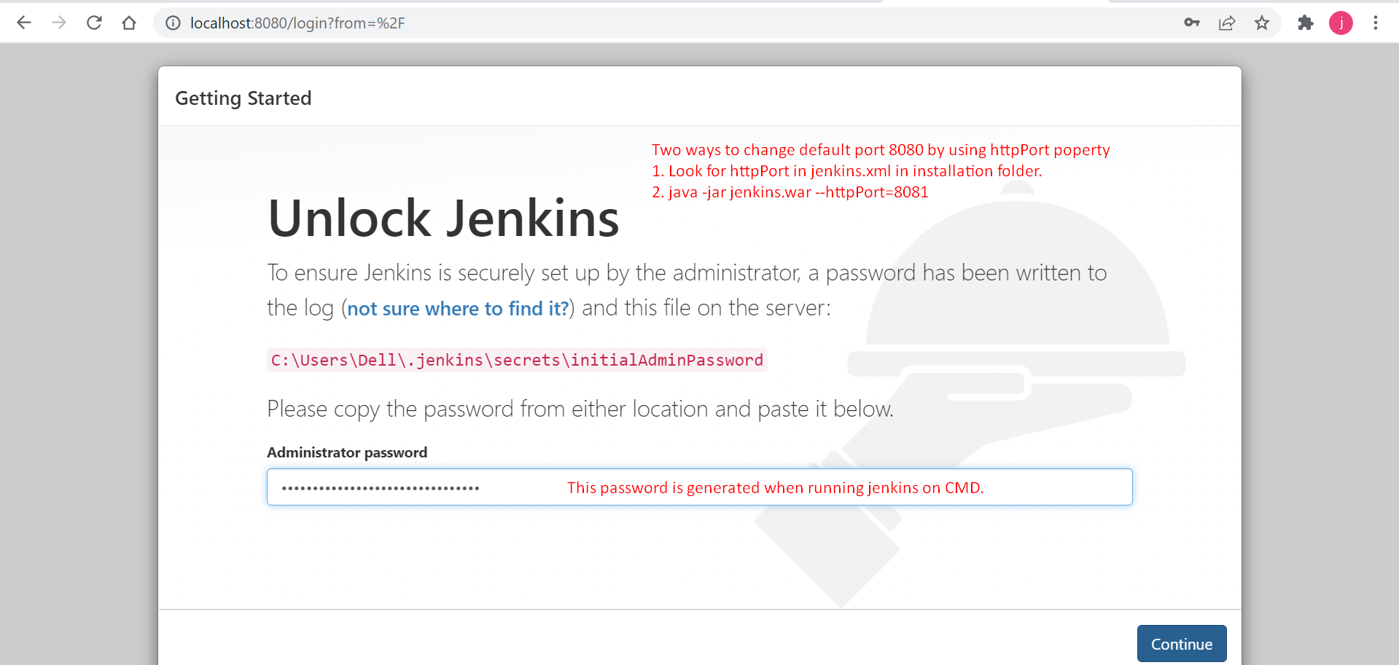
6. Now select the plugin set which suits you best.  
   For the time being, we don’t want to install plug-ins as we will be installing as per our need.
7. 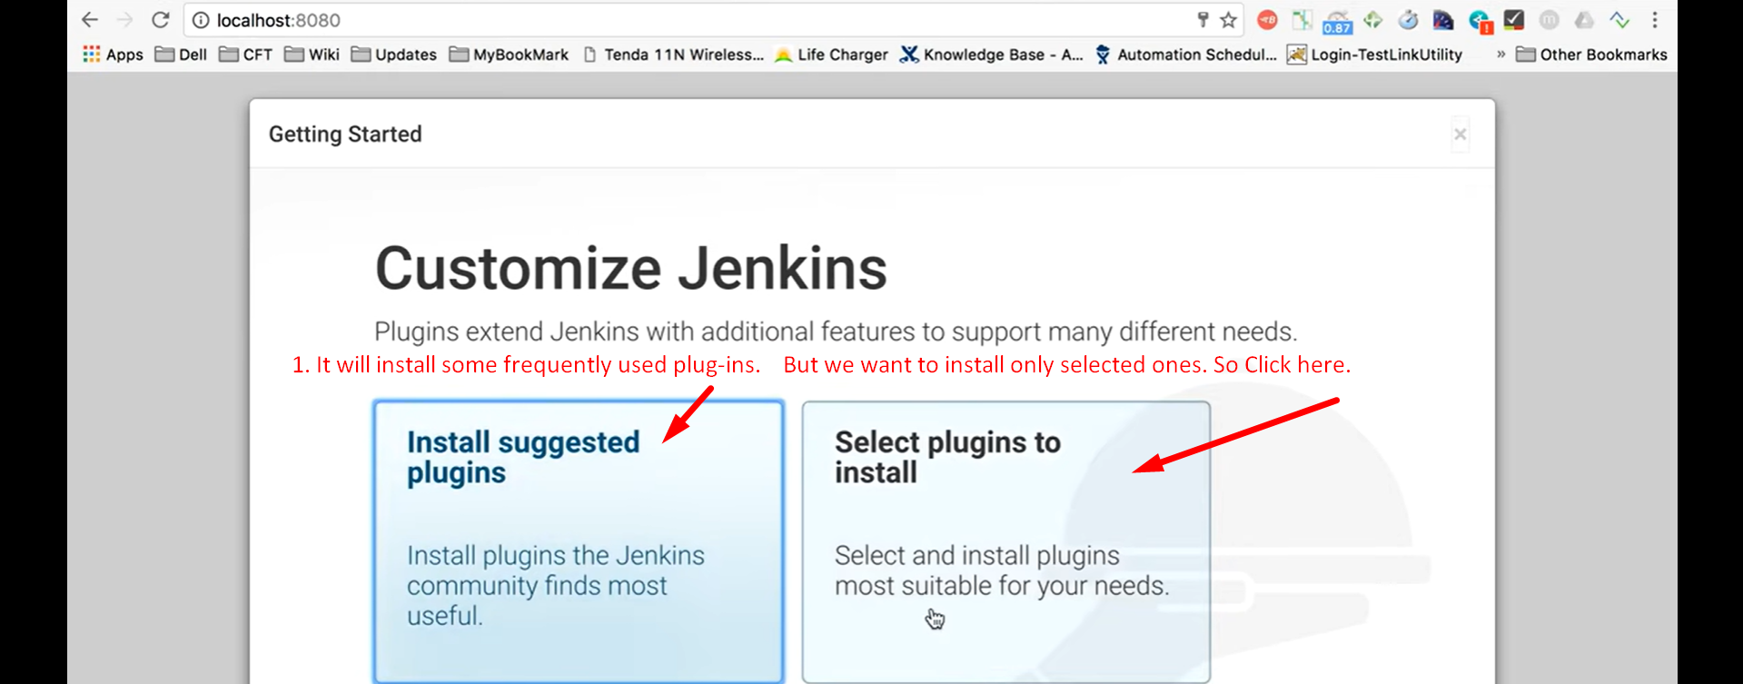
8. 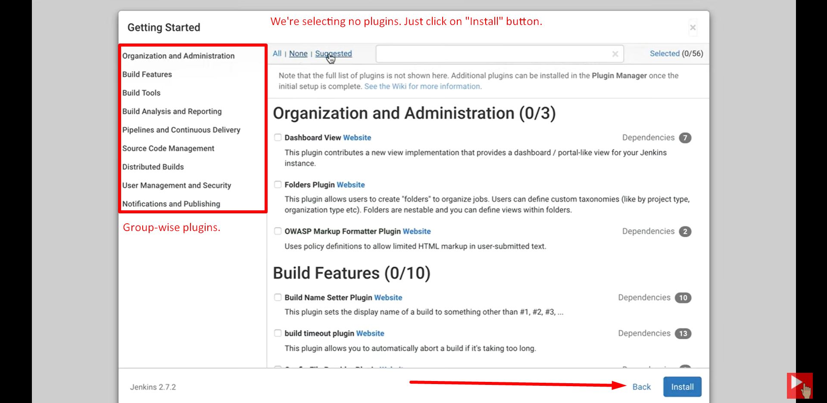
9. 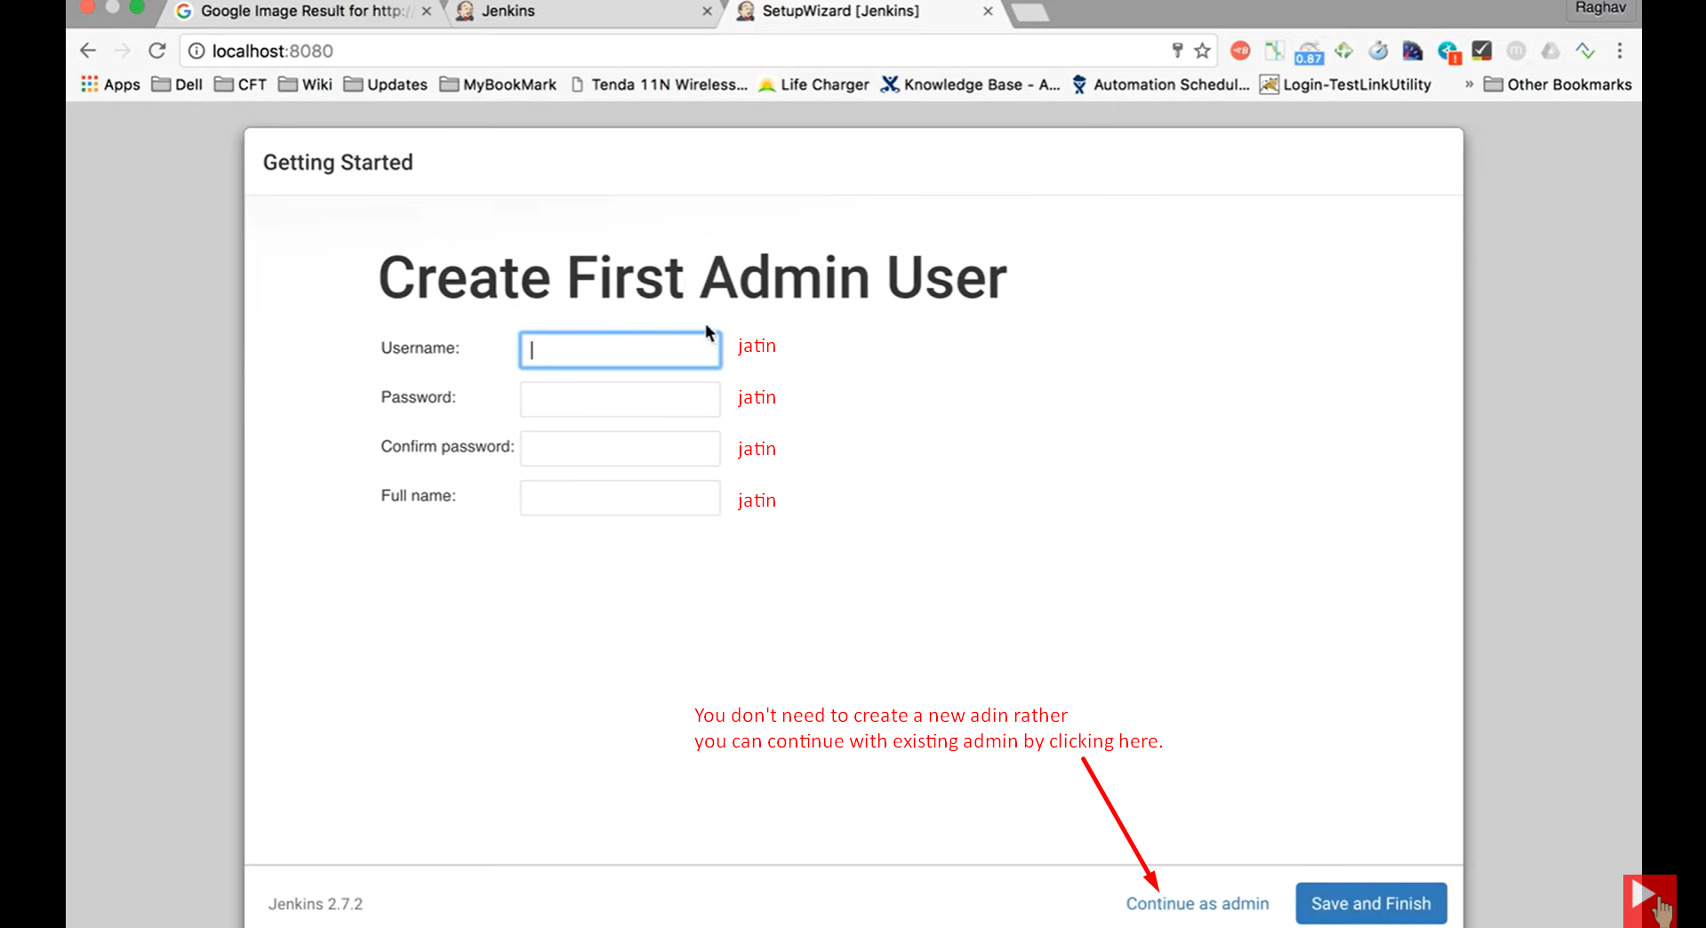
10. 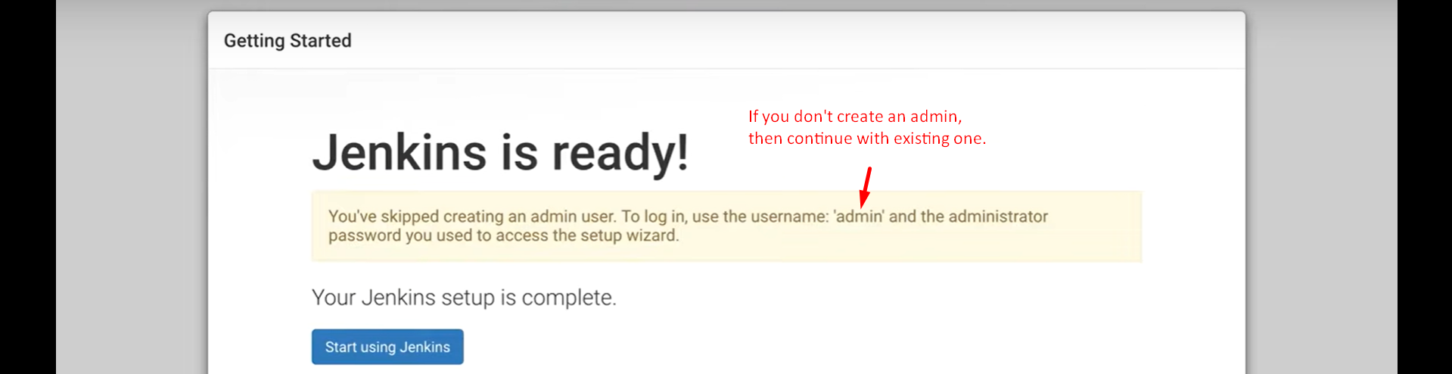
11. 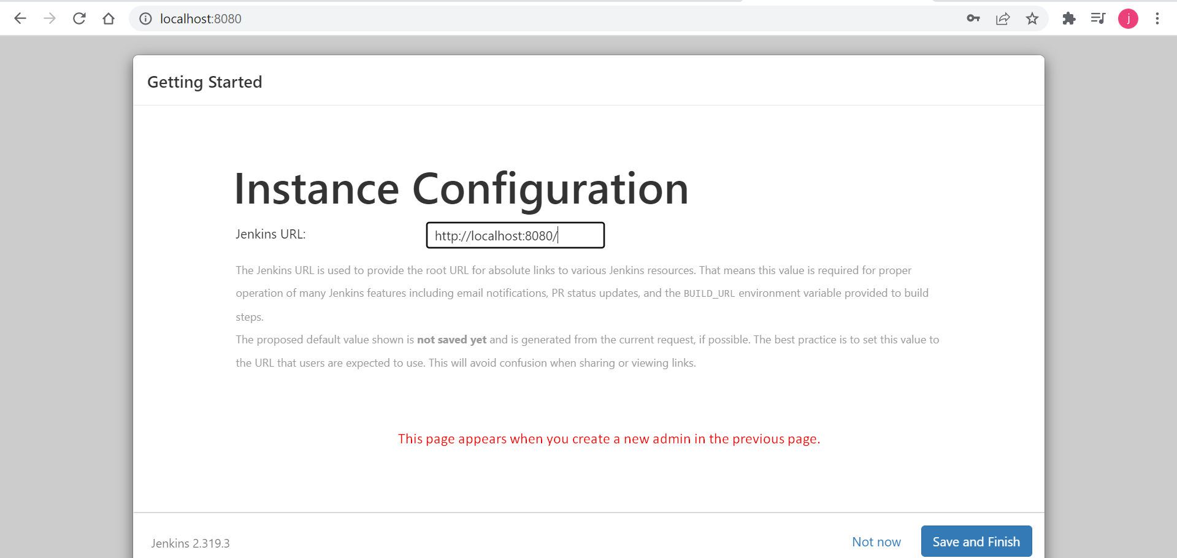
12. 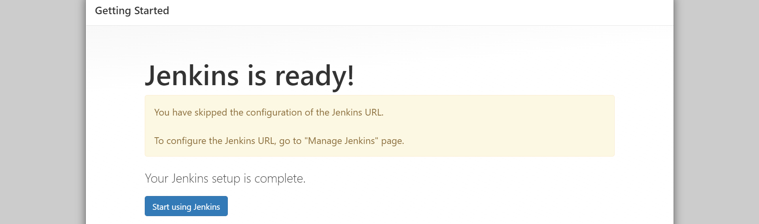
13. 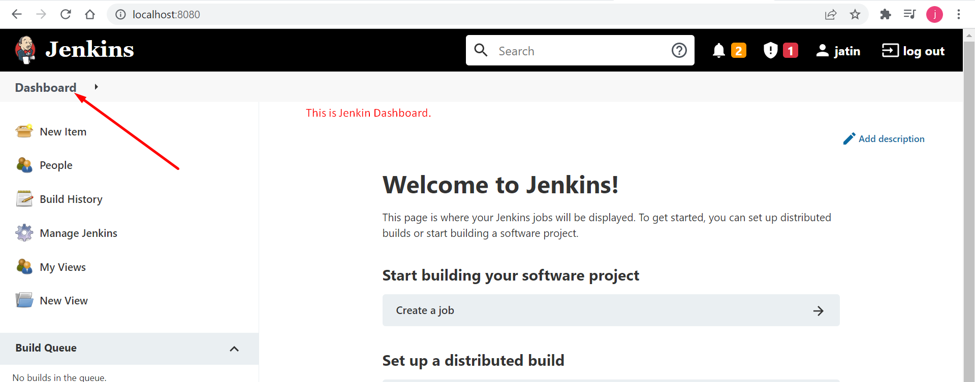
14. 